**The Garden Gate** 

**Bonner County Gardeners Association**

**Education ~ Community Service ~ Camaraderie**



**October 2015**

*Please contribute to The Garden Gate. Informational articles, garden tips, announcements, and digital photos are welcome. For questions or comments please email* [lauriebrown54@gmail.com](mailto:lauriebrown54@gmail.com) *When emailing, please put “MG” in the subject line.*

**In This Issue**

President’s Message

November Gardening To-Do List

October Meeting Minutes

**President’s Message**

There are a number of events to report on this month and a couple of business items to address. I'll start with the business items.

It is election time for officers and board of director members. All positions are open for nomination. Below I have reproduced the descriptions and duties of all positions from the Association's Procedures and Guidelines. Please nominate yourself for any position that you would like to hold. The Association is dependent on members to make it run. I have sent out an email to members requesting your input.

**ORGANIZATIONAL GUIDELINES**

Board of Directors

The Board of Directors is the principal decision-making group within the organization. The board meets monthly to develop and plan activities. The Board of directors consists of eleven members, including the President, Vice President, Secretary, and Treasurer. The remaining seven members are general board members. The members of the Board of Directors are elected per the Association by-laws. The term of the elected office is one year, from January through December. Once elected, these people are responsible for the following duties:

President

* Presides over membership meetings.
* Prepares an agenda for membership meetings.
* Chairs the Election of Officers and Board of Directors nominating committee.
* Oversees all committee activities.
* Writes the “Note from the President” article for the monthly Garden Gate.
* Maintains the Calendar of Events
* Monitors the operation and functioning of the BCGA and deals with any issues that may arise

Vice President

* Presides over meetings and takes on all presidential duties in the absence of the President.
* Assumes responsibilities as delegated by the President.
* Creates and updates an annual list of member committee choices
* Gathers and maintains the descriptions of all committee work.
* Maintains the “bible”, a collection of association papers and committee chair job descriptions.

Secretary

* Attends the monthly business meeting and any other meetings as called by the president.
* Keeps a copy of the agenda as prepared by the president.
* Makes note of any changes or corrections of last month’s minutes as given at the beginning of the meeting if any are reported.
* Keeps minutes of all business conducted at the meeting and includes the names of all members in attendance.
* Sends copy of minutes to all members attending the meeting.
* Sends minutes to the editor of the Garden Gate to be included in the next issue.
* Keeps a supply of BCGA cards and stamps.
* Sends cards from the association when appropriate and/or when requested by the president.

Treasurer

* Keeps itemized financial records of all expenditures and reimbursements.
* Prepares an end of the year report of the totals of all accounts.
* Prepares a monthly report to the board and is prepared to discuss all transactions.
* Pays bills in a timely manner.
* Reports to the IRS at the beginning of the year using form 990-n (available at [epostcard@urban.org](mailto:epostcard@urban.org))
* Reports to the State of Idaho on the card sent from the Secretary of State at beginning of each year.
* Keeps the Board of Directors aware of any problematic trends in spending and account balances.
* Manages the PayPal account
* Is responsible for any audit that may be determined necessary.
* Is responsible for monies collected at any fundraising activity, supplying the cash box and change upon request.

Board Members

* Attend monthly meetings and all meetings called by the president to discuss and vote on items concerning the Association.
* Recruit members to voluntarily serve on committees, with the exception of the nominating committee, which shall consist of the non-officers of the Board of Directors.

The next business item is membership renewal. I have also sent out the renewal form which should be returned to the BCGA office along with $20 for annual dues.

Now on to past and future activities. The Association held a field trip to Sandpoint Orchard, an orchard specializing in heirloom varieties. About fifteen members and friends attended the field trip.

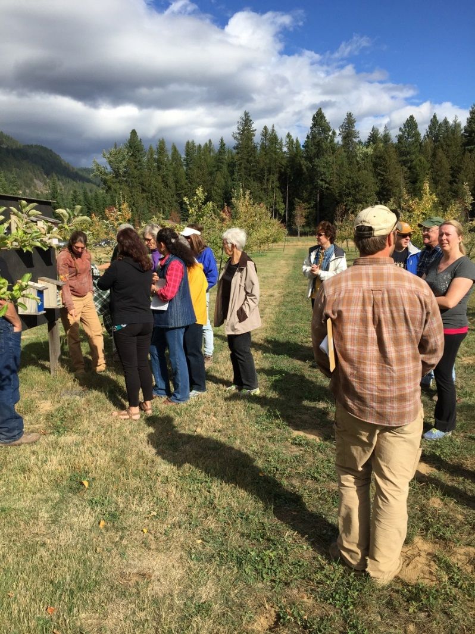

Our host was Kyle Nagy, manager of the orchard, and as one of members remarked: "easy on the eyes". The orchard is a certified organic operation located at 10881 North Boyer Avenue. It has been in operation since 2008 and sports varieties of pears, plums, cherries and raspberries in addition to it's 68 varieties of apples. New varieties are being constantly added as the orchard grows. This year they marketed their apples at Winter Ridge and Yokes.

One of the topics of interest was pruning and shaping of the trees in the orchard with discussion of various techniques and devices they use. Of course most of this activity occurs in the spring and both Kyle and the members present agreed that another trip to the orchard in the Spring, during pruning, would be informative.

Thanks to Kyle and his staff for hosting us. More information on the Sandpoint Orchard can be found at www.sandpointorchard.org and there are brochures about the orchard available in the BCGA office.

The success of this field trip raises the possibility of additional outings. I encourage you to think of future possibilities and suggest them to the membership. It is one way of further educating ourselves on various aspects of gardening.

The Harvest Party was held at the Ponderay Event Center October 16th and a number of you attended. It was an opportunity to reconnect with old members and welcome new members to the association. From the feedback received, I think that was accomplished.

That said, mark your calendars for Saturday, December 12th. That is the date for the annual Christmas dinner and party and will be held at the Event Center. I will be sending out reminders via email as that date approaches.

Other activities members have been involved with include the semi-annual highway cleanup (8 members participated this Fall) and various activities with the school gardens. Thanks to all who participated.

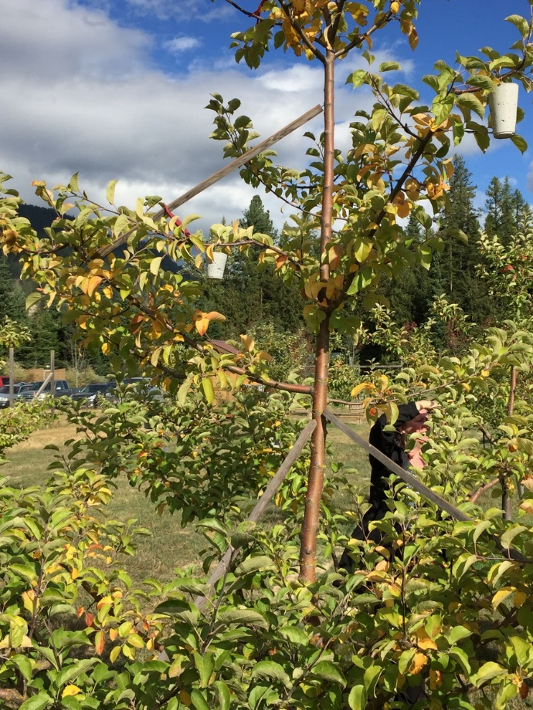

**November Gardening To Do List**



**Zone 3**

* Cut back on feeding houseplants (do not feed dormant houseplants)

**Zone 4**

* Cover perennial, vegetable, bulb, and strawberry beds for winter
* Plant winter- and spring-flowering bulbs
* Divide and replant crowded fall-blooming bulbs after leaves yellow
* Buy spring-blooming bulbs
* Cut back on feeding houseplants (do not feed dormant houseplants)
* Protect roses for winter

**Zone 5**

* Plant winter- and spring-flowering bulbs
* Divide and replant crowded fall-blooming bulbs after leaves yellow
* Buy winter- and spring-blooming bulbs
* Cut back on feeding houseplants (do not feed dormant houseplants)
* Protect roses for winter

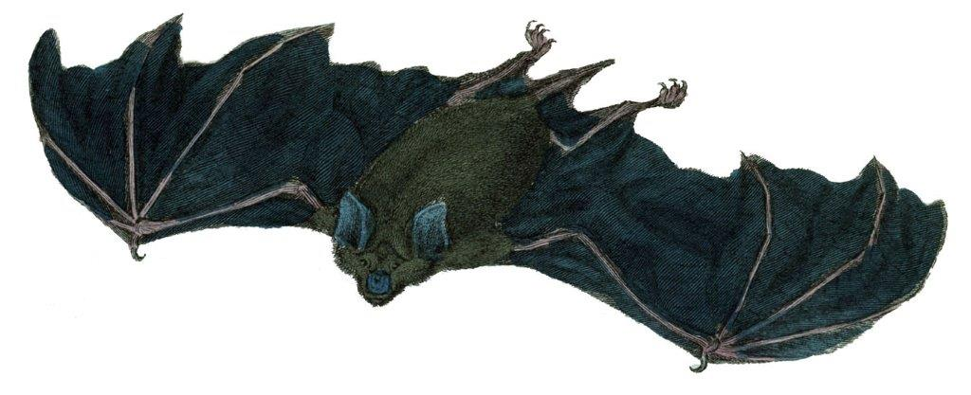

**October Meeting Minutes**

**Following are the minutes for the BCGA meeting on October 7, 2015:**

**Members Present:** Patti Pietron, Deb Steffen, Gray Henderson, Janae Dale, Gail Swan, Marjory Clements, Ann Warwick, Butterfly Burke, Cindy Hayes, Howie Fennimore, Penny Barton, Sandra Gevurtz, Pamelarose Crawford

At 9:10am October 7, 2015 President Gray Henderson brought the meeting to order.

**September Meeting Minutes**: Meeting minutes approved.

**Treasures Report:** Penny Barton reports that we are in balance for the end of September. She questioned a $120.00 bill from the Chamber. We advertise on the Chamber site so the bill in question was correct. Treasurer’s report was approved.

**School Gardens:** Janae Dale reported that the issue of the Cottonwood tree and its removal is still under investigation. A root barrier was installed horizontally at the bottom of the beds to help stop the cottonwood roots. The existing soil will need to be screened and put back into the beds. This is very labor intensive and the beds may not be ready for fall. Janae personally paid for the barrier and will investigate reimbursement from school funds.

**Home Horticulture:** Janae Dale reports she has a committee in place. She sent out a Facilitators guide to the committee members and asked for updates, corrections and changes. The classes will be held in the BCGA office. Janae and her team will meet in January to set up the agenda.

**Farmers Market:** Sandra Gevurtz that the last Farmers Market is on October 10. She expressed a need for help and Gray Henderson and Deborah Steffen said they would step up. Michele Murphree has seeds for us to give away at the booth. Gray will contact her about them.

**Potlucks:** Deborah Steffen thanked Sandra and Steve Gevurtz for the lovely potluck they hosted. Presently there are no potlucks scheduled.

**Highway Cleanup:** Gray Henderson canceled the original cleanup due to high winds. Cindy Hayes has rescheduled the cleanup date for Thursday, October 8. The team will meet at 9:30 at Sears to carpool, or 10:00 at the Blue Heron. The team will clean one side of the highway. Gray will send out an email reminder to the membership.

**Old Business:**

**Bike Raffle:** Gray Henderson said the raffle made $2,300.00. It will go to fund the school gardens

**Orchard Tour:** Gray Henderson reports that the tour of Sandpoint Orchards was a success and is working on scheduling one for spring. He encouraged anyone with an idea for a field trip set one up and present it to the membership.

**Jan Wilfert:** There were 18 members present at the home of Jan Wilfert to clean up the garden and put it to bed for the winter. Cindy Hayes has a few pots left for distribution to members that would like some. Jan’s husband Rick was very appreciative of all the hard work.

**New Business:**

**Elections:** Gray Henderson will step down as president in January. Deborah Steffen will also step down as vice president. Gray will send out an email to the membership for nominations for officers for 2016.

**Dues:** Gray Henderson will send out a reminder that our $20.00 dues are due and will attach a volunteer form to the email.

**Harvest Party:** Penny Barton is moving ahead on the Harvest Party that will celebrate autumn and welcome new members. BCGA will provide a main dish and a side dish. Partygoers are requested to bring a dish as well. Penny asked for help decorating the space on Friday, October 16 at 10:00am.

Meeting adjourned at 10:25.

**Arboretum:** Gray Henderson has had a request from Joyce Pence that BCGA members put in some volunteer time at the Arboretum. Cindy Hayes will contact her to explore this request.

**Scholarship:** Cindy Hayes requested that the subject of a scholarship in Jan Wilfert's name be added to next month’s agenda.

**Christmas Party:** Gray Henderson has set the date! Mark calendars for December 12.

Meeting Adjourned: 10:55

*Work day at Jan Wilfert’s, putting the garden to bed for the year: Rick Wilfert, Bob and Johna Diderich, Penny Barton, Jenna Bertus, Shirley Barksdale, Becky Reynolds, Gail Swan, Jan Geren, Brenda (neighbor), Ann Warwick, Christine Winslow, Butterfly Burke, Sandra Gevurtz, Patti & Carl Pietron. Not pictured: Lynn Pietz and Cindy Hayles.*

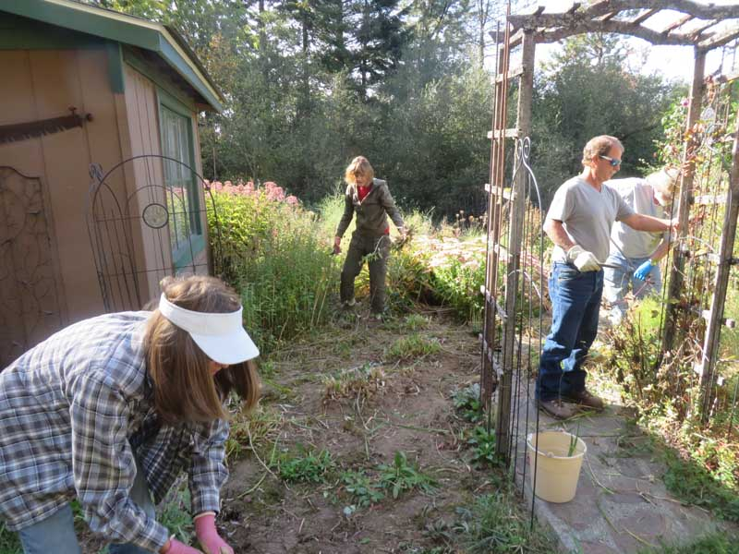

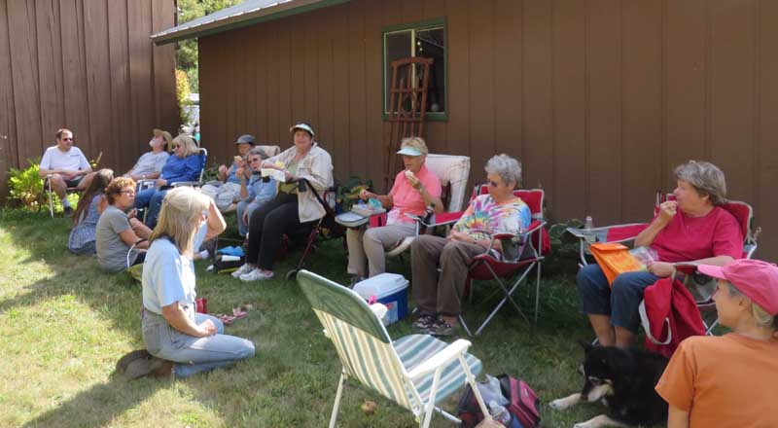

*“Autumn arrives, array’d in splendid mien;*

*Vines cluster’d full, add to the beauteous scene,*

*And fruit trees cloth’d profusely laden, nod,*

*Compliant bowing to the fertile soil”*

Unknown; from Farmer’s Almanac

Got bats in your belfry? Fall is the time to get rid of them; watch them fly out to feed at dusk and close up the entrance while they are out. Do not do this during the summer as baby bats get left in the colony while adults feed and you’ll shut them in. Shutting them out allows them to find a new home (you can provide them with a bat house!), whereas hiring an exterminator means they get killed and you lose valuable insect controlers!

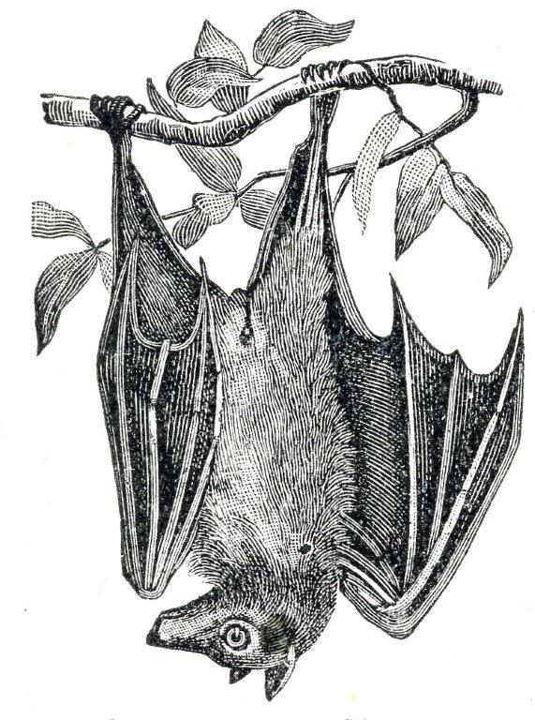

*“Lately, I have had a special interest in extending the period in which the garden is attractive further into autumn. Normal people admire sugar maples or watch football games in fall. My taste runs more toward combating seasonal senescence in the garden, delaying the inevitable, and more positively, preserving beauty.”*

Frederick McGourty, Jr., American Horticulturist Magazine, February 1985