**The Garden Gate** 

**Bonner County Gardeners Association**

**Education ~ Community Service ~ Camaraderie**



**May 2016**

*Please contribute to The Garden Gate. Informational articles, garden tips, announcements, and digital photos are welcome. For questions or comments please email* [lauriebrown54@gmail.com](mailto:lauriebrown54@gmail.com) *When emailing, please put “GG” in the subject line.*

**In This Issue**

President’s Message

June Gardening To-Do List

May Meeting Minutes

Hot Spot: Jane Roach

Birthdays!

Musing of a Gardener

**President’s Message**



**President’s Message**

BCGA Spring Plant Sale was held on Mother Day’s weekend. Through Penny Goodman and Marjory Clements leadership, and record breaking number of plant donations, we cleared over $1500 dollars. A bouquet of flowers to “the crew” Howie/Tonnie, Ann, Gray, Gail S., Butterfly, Shannon, Jenna/Dave, Cindy, Peggy, Tim/Deborah and Janae, A Big Thank You to all who bought plants and helped make this event a huge success.

The theme for this year’s Bonner County Fair is From Farm Gate to Dinner Plate. Barb Pressler will chair the first meeting of her committee May 25 at the BCGA office. There’s always room to one more if you’d like to join the brainstorming sessions. It’s always exciting to see the booth take shape.

The Blueberry Home Hort class filled all the chairs in the room. Despite the heat generated from all those bodies, it was an enthusiastic audience. However, at the following Membership Meeting we voted to purchase a box fan. Gail Swan surprised Howie with a gift in appreciation for his loyal service in setting up and participating in all the Home Hort classes.

Shirley Barksdale has stepped up to fill the vacant Board Member seat. Thanks Shirley!

The Highway cleanup was rescheduled due to weather. Ten volunteers cleaned up one side of our designated 2 mile stretch and filled 21 bags of trash. Thanks Tim and Deborah for heading up the team and hauling/setting up the heavy metal Hwy signs.

Farmers Market has started for the season. BCGA will have a booth on May 14. Sandra Gevurtz will have handouts. Wear your t-shirts with the BCGA logo. There are large and small iron on BCGA logos available at Sand Creek Custom Wear on Cedar St.. Free to members.

The Garden Tour map is close to being finalized. The date will be Sunday July 17 not July 3. We’re breaking with tradition. This year more homes were available after July 4th weekend.

Gray Henderson helped the sixth graders fill the new raised beds at Sagle Elementary School. There’s a dedicated group of BCGA volunteers who help the teachers and students learn both the joys and hard work of gardening. There’s a need for more volunteers to help. Maybe you can find a niche.

Look for the Spring/Summer issue of Sandpoint Magazine that will hit the stands May 18. There is an article about the community of gardeners in Bonner County. BCGA will be included. Marlisa Keyes is a BCGA member.

The Yard Sale is fast approaching and we’re in need of donations. Check your closets and garage for items to donate now. Take your “treasures” to Cindy Hayes/Bob Blair’s barn where we’ll sort and price in August.

The Native Plant Sale is June 4 at the Arboretum/Museum.

In June we will be celebrating BCGA’s 5th anniversary. More details to follow.

Here’s a bit of trivia about our logo. The BCGA logo consists of three components: grass, seven-petal flower and huckleberry leaves. Each of the components represents our tagline which is “Education- Community Service – Camaraderie”. The grass seeds spread seeds of knowledge. The flower has seven points representing our seven aspects of community service: Home Hort Workshop series, Information Booths, Public Presentations, Garden tour, School Gardens, Internal Continuing Education and Beautification Projects. Huckleberries represent group effort in working together to gather berries and share the benefits.

Cindy Hayes – President of BCGA

[cmhayes63@gmail.com](mailto:cmhayes63@gmail.com)

2631104

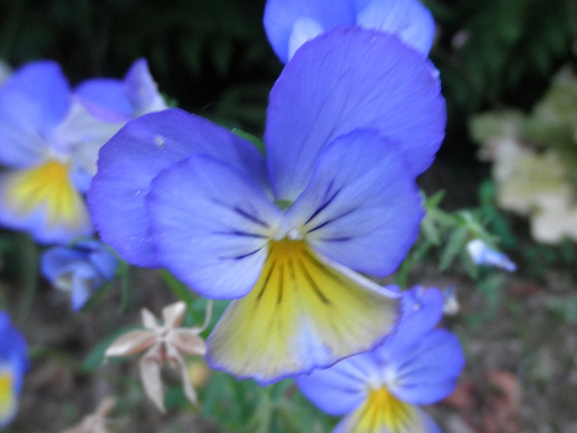

**June Gardening To Do List**



Zone 4

Plant seedlings of warm-season annuals and vegetables

Sow seed of fast-growing, heat-loving herbs, vegetables (basil, squash, melons) and flowers (nasturtiums, zinnias) directly in ground

Thin out small green fruits on apple, peach and plum trees to one every 6 inches on the branch

Dust potato plants to prevent infestations of potato beetle

Set up trellises to support pole beans, morning glories and cucumbers

Remove newest shoots from geranium plants to encourage fuller plants

Plant new lawns and fertilize and aerate established lawns

Plant container roses, shrubs and trees in well-amended soil

Divide and transplant spring-flowering perennials that have finished blooming

Protect cole crops (cabbage, broccoli, kale) from egg-laying cabbage white butterflies with insect-barrier cloth

Weed asparagus and strawberry beds

Remove new flower buds from chrysanthemums and carnations to coax bigger blooms

Zone 5

Divide and transplant spring-flowering perennials that have finished blooming

Harden off and plant seedlings of warm-weather vegetables and flowers

Thin out small green fruits on apple, peach and plum trees to one every 6 inches on the branch

Sow seeds of perennials directly into the ground

Dust potato plants to prevent infestations of potato beetle

Pinch newest shoots on geranium plants to encourage fuller plants

Train your lawn to grow deep roots; Mow often, at a high setting

Plant balled-and-burlapped and container shrubs and trees

Feed roses as the first flower buds appear; apply fungicide to prevent powdery mildew or blackspot

Weed asparagus and strawberry beds

Feed young corn plants with high-nitrogen fish emulsion fertilizer

Mulch flower and vegetable gardens to conserve water during heat waves

**May Meeting Minutes**

**Following are the minutes for the BCGA meeting on May 4, 2016:**

**Members Present**: Gail Swan, Shirley Barksdale, Butterfly Burke, Howard Fennimore, Gray Henderson, Barbara Pressler, Marjory Clements, Tim Gift, Bruce Greene, Penny Goodman, Penny Barton, Cindy Hayes, Gordon Fish, Sandra Gevurz, Ann Warwick.

President Cindy Hayes brought the meeting to order at 9:04 am.

The April minutes were approved via motion by Penny Barton, seconded by Penny Goodman, and unanimously approved.

**Treasurer's Report**: Current balance in checking account is $1358.09. The Home Horticulture classes have contributed to an increase.

**Committee Reports:**

` **Home and Garden Show** (Ann Warwick): Our booth featured a new format this year. Instead of offering mini classes, we chose a theme--Soil-- and created a display on this topic. Deborah and Tim Gift designed a three-fold poster for BCGA, which explains who we are and what we do, which was displayed in the booth. Successful event.

**Fair Booth** (Barbara Pressler): Committee will meet on May 25, 9:00 at the office to discuss the booth design. Interested people are encouraged to attend.

**Home Horticulture Classes** (Gail Swan): Last class on May 4. Good attendance, average 20 per class, with 50 attending the blueberry class. Gail awarded Howard Fennimore a gift as thanks for all the work he does at every class. Kudos to Howie!

**Sip 'n' Shop** (Deborah and Tim Gift) : We made about $215 total, with our share of the evening sales and the raffle tickets. Suggested a June date as more productive with more people in town. Question: to continue? Consensus was a big "Yes." Motion by Howard Fennimore to continue, seconded by Gray Henderson. Unanimous vote in favor.

Vacant seat on board filled. We welcome Shirley Barksdale to the BCGA board.

**Healing Garden** (Gail Blasingame): The project could use more volunteers.

**Mickinnick Trail** (Jan Griffitts): No report.

**Native Plant Society Arboretum** (Joyce

Pence): The Native Plant Society will have a plant sale and Arbor Day celebration (delayed) on June 4, at the arboretum. Brochure and map of plant areas is now available. Article coming in Sandpoint Magazine featuring NPS and BCGA, among other gardening organizations.

**Spring Plant Sale** (Penny Goodman, Marjory Clements): Sale on Friday and Saturday, May 6 and 7 at the eastern side of the Bonner Mall. Weather looks okay.

**Raffle Basket Fundraiser** (Becky Freeland): Tickets selling, we will take the basket to the plant sale.

**Media Outreach** (Tim Gift, Gordon Fish, Laurie Brown, Shannon Callister): Need ideas for Facebook and Garden Gate. Articles welcome. Laurie had an article in The Reader.

**Highway Cleanup** (Tim Gift): Ten people showed up, got the job done in an hour and a half.

**Fairgrounds project** (Penny Barton): No report.

**Speakers Bureau** (Marrion Newsom-Banks): No Report

**Farmers Market** (Sandra Gevurz): We will have a booth at the market during special events, about once a month. May 14 projected for our first appearance.

**Membership Class** (Penny Barton): The new badges are ready for the graduates. Fall party? We have 40 possible students for 2017. Room capacity is 17 for the class. Monday and Friday will be the days of classes.

**Garden Tour (**Pat Congleton and Gaia Swinford): Date to be July 17. Some gardens lined up, finalizing plan.

**School Gardens** (Gray Henderson): Picture of Sagle garden in Garden Gate; Bonner County Daily Bee Picture of Gray Henderson and kids. Elisa Wadds is the only volunteer at Farmin-Stidwell. Another volunteer or two would be welcome. All schools doing well.

**Yard and Plant Sale** (Janae Dale): No report. Take yard sale offerings to the home of Cindy Hayes and Bob Blair. Call first.

**Potlucks** (Deborah Steffen): May be one in June.

**Old Business**:

**BCGA Logos**: Available at the T shirt shop. We have 38 large logos and 36 small.

**Caller ID** (Penny Barton): Now in place. Helps a lot in capturing messages.

**Jan Wilfert Memorial** (Cindy Hayes): Members selected a picture to put in a frame with a plaque for the office wall.

**Field Trips**: To be discussed next meeting.

**Sandpoint Magazine** (Cindy Hayes): Article to appear on May 18 covering various gardening groups locally.

**Bible conversion to electronic format** (Tim Gift, Gordon Fish, Gray Henderson): We will acquire some helpful software. Project in process. BCGA information currently only in the notebook in the office. This will make it available electronically. Motion to invest in software by Penny Barton, seconded by Gail Swan. Voted on and passed.

**New Business**:

**Marketing our organization** (Cindy Hayes, Janae Dale): New business cards, thanks to Tim Gift. Suggest we develop a three fold brochure to hand out at events. More articles in Reader, Sandpoint Magazine, etc. Low key ideas--wearing logo, word of mouth, etc.

**Motion:** Room gets stuffy, so Gray Henderson moves to purchase a box fan for the window. Seconded by Penny Barton. Voted and Passed.

**Recent use of logo by other organization** (Gail Swan): Our logo was used to advertise classes given by others. Cindy Hayes, president, will discuss this with the entity that used it. We will look into a trademark for the logo.

**BCGA Anniversary in June**: Party planned at a member's home. Potluck.

**Request for Garden to Photograph** (Penny Barton): Mr. Kim Peterson from Sandpoint Photo Club, seeks an attractive garden to photograph. Phone: 391-1440. Cindy Hayes will send out an email.

**Computer issues** (Gail Swan): Our laptop is getting old and slow. Needs cleaning up. Gray Henderson volunteered to work on it.

Meeting adjourned at 10:47 am.

**Hot Spot**

Jane Roach

335 Terrapin Station, Sagle, ID 83860

263-2748

[jane@roach.net](mailto:jane@roach.net)

Born and raised in Minnesota, after graduating from the University of Minnesota I joined the United States Air Force to see the world. I did to get to see half of it, the Far East. My career as a physical therapist was spent mainly in California until 2004 when my husband, Dick, and I joyfully retired to the country life in North Idaho. I was determined to understand the local flora and fauna and became an Idaho Master Gardener. Every year starts with a vision of the most wonderful garden and landscape, and all summer I look for what went wrong. This battle with nature includes rain or the lack of, snow or the lack of, bees or the lack of, deer, elk, moose and this year a new beaver who has his own preferred landscaping. I also joined the Idaho Writers League and write on travel and nature. My long time project is a historical novel based on my family homesteading in Alberta, Canada in the 1900s

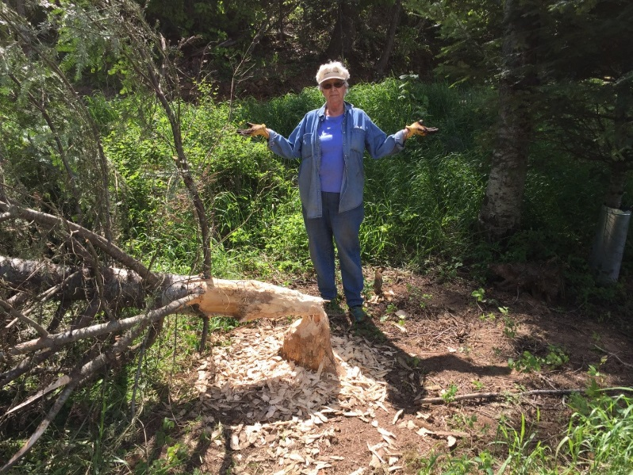

**Musings of a gardener – May 2016**

In addition to the aura of romance that surrounds a full moon, different cultures have popular names for each moon cycle.



The names were applied to the entire month in which each occurred. The Farmer’s Almanac lists several names, and explains that there were some variations in the moon names, but in general, the same ones were used among the Algonquin tribes from New England on west to Lake Superior. European settlers followed their own customs and created some of their own names.

Northern Hemisphere full moon names by month:

**January**: Old Moon, Moon After Yule*, *Holiday Moon*

**February:** Snow Moon, Hunger Moon, Wolf Moon, *\*budding moon*

**March:** Sap Moon, Crow Moon, Lenten Moon, *\*sleepy moon*

**April:** Grass Moon, Egg Moon, Pink Moon, *\*peony moon*

**May**: Planting Moon, Milk Moon, *\*dragon moon*

**June**: Rose Moon, Flower Moon, Strawberry Moon, *\*lotus moon*

**July:** Thunder Moon, Hay Moon, *hungry ghost moon

**August:** Green Corn Moon, Grain Moon, *\*harvest moon*

**September**: Fruit Moon, Harvest Moon, *\*Chrysanthemum* moon

**October:** Harvest Moon, Hunter’s Moon*, *kindly moon*

**November**: Hunter’s Moon, Frosty Moon, or Beaver Moon, *\*white moon*

**December**: Moon Before Yule, or Long Night Moon, *\*bitter moon*

* Italicized names were given by the Chinese

In the Southern Hemisphere where the seasons are switched, the Harvest Moon occurs in March and the Cold Moon occurs in June.

Southern Hemisphere full moon names by month:

**January:** Hay Moon, Buck Moon, Thunder Moon, Mead Moon

February (mid-summer): Grain Moon, Sturgeon Moon, Red Moon, Wyrt Moon, Corn Moon, Dog Moon, Barley Moon

**March**: Harvest Moon, Corn Moon

**April:** Harvest Moon, Hunter’s Moon, Blood Moon

**May:** Hunter’s Moon, Beaver Moon, Frost Moon

**June**: Oak Moon, Cold Moon, Long Night’s Moon

**July:** Wolf Moon, Old Moon, Ice Moon

**Augus**t: Snow Moon, Storm Moon, Hunger Moon, Wolf Moon

**September**: Worm Moon, Lenten Moon, Crow Moon, Sugar Moon, Chaste Moon, Sap Moon

**October:** Egg Moon, Fish Moon, Seed Moon, Pink Moon, Waking Moon

**November**: Corn Moon, Milk Moon, Flower Moon, Hare Moon

**December:** Strawberry Moon, Honey Moon, Rose Moon

About once every 19 years, February has no full moon at all.

Moreover, in 7 out of every 19 years, two full moons will fall in the same calendar month. And in a year where February has no full moon at all, like in the year 2018, you can actually have two full moons in January and two full moons in March. The second of the month’s two full moons is popularly referred to as a Blue Moon.

**Road Crew!**

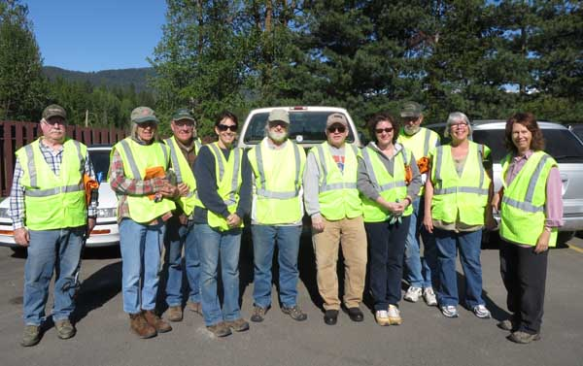

Hard working BCGA crew posed for a picture

before tackling roadside cleanup. We filled 21 bags with trash. Tim Gift , 5th from right, chairman.

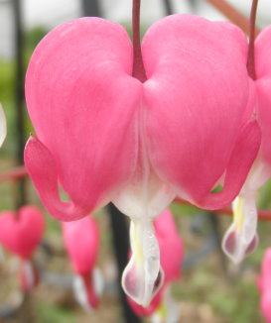

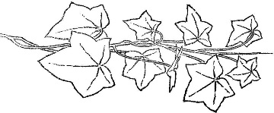

**May Birthdays!**

Cindy Hayes



*“O gallant flowering May,*

*Which month is painter of the world,*

*As some great clerks today.”*

Unknown