**The Garden Gate** 

**Bonner County Gardeners Association**

**Education ~ Community Service ~ Camaraderie**



**July 2015**

*Please contribute to The Garden Gate. Informational articles, garden tips, announcements, and digital photos are welcome. For questions or comments please email* [lauriebrown54@gmail.com](mailto:lauriebrown54@gmail.com) *When emailing, please put “MG” in the subject line.*

**In This Issue**

President’s Message

August Gardening To-Do List

July Meeting Minutes

**President’s Message**

Just four items for this month's message.

The first is the upcoming plant and yard sale. It will be held August 14th starting at 8:30. You've already seen the request for perennials and fall veggie starts to sell at the sale. Good quality used items are also requested. I know I've looked in my garage and have seen a number of items that will head that way. It will be held in front of the alternative high school on Boyer near Super 1. If you have yard sale items to donate it would be preferable to take them to Bob Blair's house before the sale so they can be properly priced. However, if that is not possible just bring them to the sale.

There are two potlucks scheduled. the next pot luck will be held Sunday, July 25th at 12:30 at Steve and Sandra Gevurtz's house. Then on Sunday, August 2nd Loie De La Vergne's will be our host at 2 PM. See Deb Steffan's recent announcement for details.

The fair is almost upon us and Cindy Hayes' fair committee has been at work planning our booth. The theme is Grand Openings at "The Seasons". Contact Cindy at cmhayes63@gmail.com if you would like to help set up, take down, or man the booth. And, make sure to stop by when you are at the fair.

Finally, August 3rd is the Northside School's garlic festival. It starts at 10 AM and I am sure there will be a lot to harvest besides garlic. The kids planted 13 (I think) varieties of beans; surely some of those will be ready by then. Thanks to Deborah Gift and Gail Burkett for the work they have put in on the garden.

Hope you are enjoying this hot, dry summer!



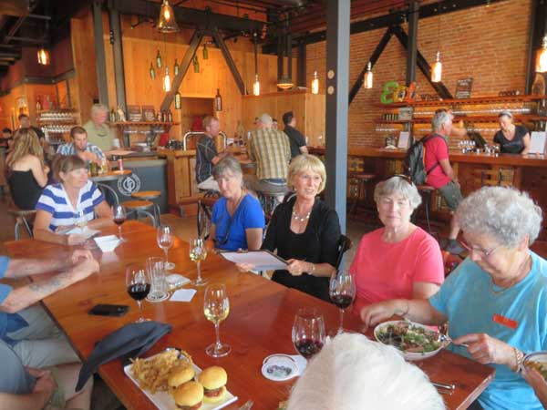

*Here are some BCGA members enjoying the camaraderie, which is one of our three prongs mission for BCGA. Patti, Kate, Deb, Tonnie watch Gail as she digs into her salad at Pend d' Oreille Winery for the June 2015 Sip and Shop BCGA fund raiser.*

**August Gardening To Do List**



**Zone 3**

* Sow seeds of wildflowers, spring-blooming annuals and fall veggies
* Lift, divide and transplant perennials
* Plant hardy Oriental and Asiatic lilies
* Aerate, dethatch and fertilize the lawn
* Start moving houseplants and other tender plants indoors to acclimatize
* Pick herbs to dry for winter soups, stews and baking
* Order trees and shrubs now for fall planting
* Plan ahead for an extended harvest by building or buying a cold frame
* Blanch tomatoes for freezing and canning by boiling them for just a few minutes and slipping off the skins
* Order spring bulbs to force indoors

**Zone 4**

* Lift, divide and transplant perennials
* Order peonies for fall planting
* Divide and transplant bearded iris
* Start moving houseplants and other tender plants indoors to acclimatize
* Enjoy a case of the late summer "blues" with a palette of aconitum, caryopteris, fall asters and reblooming iris in your planting schemes
* Blanch tomatoes for freezing and canning by boiling them for just a few minutes and slipping off the skins
* Plant fall-blooming crocus and colchicum for late-season flowering
* Prepare beds for planting bulbs and divide any existing bulbs that might be overcrowded
* Build up weather resistance of trees and shrubs with deep waterings now throughout the fall
* Look forward to something different next spring: try alliums in your bulb garden

**Zone 5**

* Sow seeds of fall vegetables
* Order peonies for fall planting
* Divide and transplant bearded iris
* Plan perennial beds for fall and winter color with ornamental grasses, fall-blooming bulbs and hardy heaths and heathers
* Harvest vegetables continuously to stretch their season
* Sprinkle compost starter to speed up composting for fall soil building
* Prune summer-blooming shrubs (hydrangea, clethra, caryopteris) after flowers finish
* Plant garlic now for spring harvests
* Look forward to something different next spring: try alliums in your bulb garden
* Enjoy a case of the late summer "blues" with a palette of hardy ageratum, caryopteris, fall asters and reblooming iris in your planting schemes 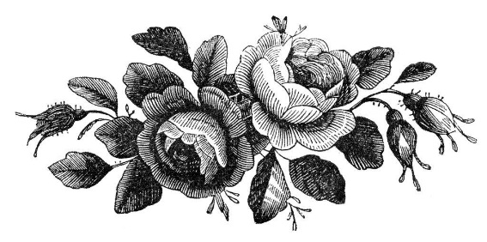

**July Meeting Minutes**

**Following are the minutes for the BCGA meeting on July 3, 2015:**

**Members Present:** Patti Pietron, Deb Steffen, Gray Henderson, Gail Swan, Barb Pressler, Marjory Clements, Ann Warwick, Butterfly Burke, Cindy Hayes, Janae Dale, Sandy Anderson

At 9:05am June 3, 2015 President Gray Henderson brought the meeting to order.

**June Meeting Minutes**: Minutes approved with corrections to be made: Cindy Hays to Hayes and Carl Burkett to Carl Hanson.

**Treasures Report:** Penny Barton was not present. Currently we have about $1,900.00 in our checking account. We will have a formal report at the next meeting.

**Home Horticulture:** In response to the survey Gail Swan said we received about 15% response rate from the membership and around 20% response rate from the public. She said everyone thought the classes were great, Wednesday night is a good night to hold the class, BCGA should just offer the series in the spring and forego offering the series in the fall. She said that most everyone said what would be a great help would be reminder emails sent out a few days before each class. Janae Dale and Gail are considering holding the class in our office to avoid room rental fees. Gray Henderson will check on the room capacity. Penny Barton has the income breakdown for the series and we’ll hear from her at the next meeting.

**Farmers Market:** Sandra Gevurtz was not present. Gray Henderson to contact her to see if she needs help for July. Janae Dale said she is signed up to work the booth in July.

**Garden Tour:** Gray Henderson said he and Penny Barton possibly have someone who will chair this event, provided that members divide up the tasks between them so the chairperson isn’t doing everything. Gray and Gail Swan have had calls and questions regarding the tour for this year. The interest from the public is there. Gray says we should start on next year’s tour in the near future. Ann Warwick suggested we request members to keep their eyes open for gardens to include.

**Yard and Plant Sale:** Janae Dale is chairman. Janae will be sending an email to members asking for starts for this event. Plants can be dropped off the night before of the morning of the sale. Items for the sale may be dropped off at Cindy Hayes and Bob Blair’s home. Janae wants the focus on the sale of plants. She asks members to think of plants that can be planted in the fall. Janae or Penny will ask Valle Novak to do an article on fall perennials. The sale is on August 14 and starts around 8:30 am.

**School Garden Program:** Janae Dale says she received reports from the schools and that they are doing well. Gray Henderson thanked Janae for doing such a great job. Janae says she has lots of wonderful help. New member Deborah Gift provided snacks for the Strawberry Festival at Northside on June 22. The Garlic Festival on August 3 is at Northside.

**Potlucks:** Deborah Steffen hosted a potluck at her home on Sunday June 14 at 1pm. There was a good turnout and everyone enjoyed touring her lovely garden, meeting her very cute chickens, and savoring all the yummy treats members brought. We will have another potluck on August 2 at the home of Loie De La Vergne, Deb will send out the details to members.

**Fair:** Cindy Hayes is chairman. Cindy and her team have an action plan! The booth theme is Grand opening of "The Seasons".  They'll follow through the movie theme with Shady characters and Sun loving divas, Act I,- Act 4 (reflect the seasons), props, roll out the carpet (cover plants) etc. The booth will be manned Wednestay through Saturday but not on Tuesday. Shifts are in 2 hour increments. Cindy created a sign up sheet for members who want to help with set up, take down, and shifts. Gray Henderson will send it to the membership. The booth will contain some educational activities this year.

**Sip and Shop:** Cindy Hayes is chairman. Cindy this event made $456.00 for BCGA. The winner of the basket was thrilled! Marge Clements suggested Cindy ask Chris about putting an article in the Bee regarding the winner and her prize. Cindy will ask the lucky lady if she would be ok with having an article and picture in the Bee. Gray Henderson commended Cindy for the job she did with this event.

**Highway Cleanup:** Cindy Hayes said she is looking ahead to our next scheduled cleanup. She is considering the end of September or sometime in October. Feedback from members would be appreciated regarding the next date.

**New Business:** Gray Henderson mentioned that there was no word on the library cleanup. Janae Dale said that our files could use cleaning up as well.

Janae Dale wanted it noted that the BCGA was left out of the magazine the Bee puts out. This publication lists events and clubs in Bonner county. Janae will ask Chris about this.

Meeting adjourned at 10:55.

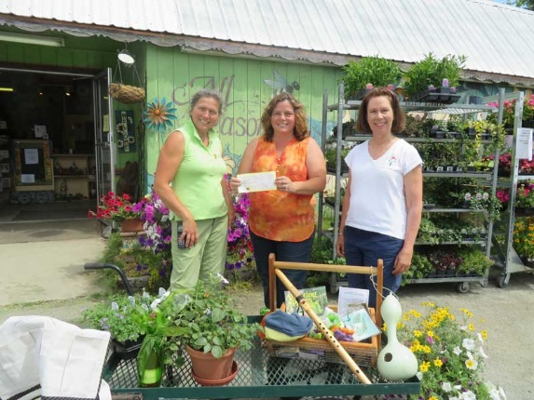

*The raffle basket & thrilled winner!*