**The Garden Gate** 

**Bonner County Gardeners Association**

**Education ~ Community Service ~ Camaraderie**



**January 2017**

*Please contribute to The Garden Gate. Informational articles, garden tips, announcements, and digital photos are welcome. For questions or comments please email* [lauriebrown54@gmail.com](mailto:lauriebrown54@gmail.com) *When emailing, please put “GG” in the subject line.*

**In This Issue**

February Gardening To-Do List

January Meeting Minutes

Hot Spot: Marjory Clements

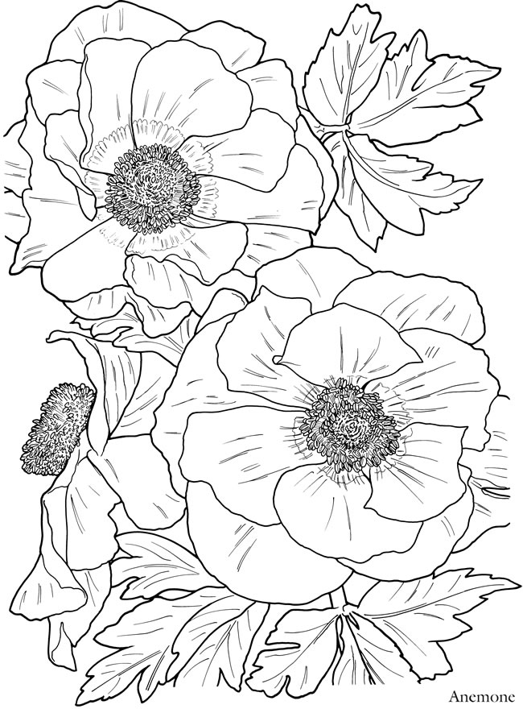

**February Gardening To Do List**



**Zone 3**

* Order seeds
* Cut back on feeding houseplants (do not feed dormant houseplants)
* Water cymbidiums weekly until they bloom
* Sow seeds for tender perennials

**Zone 4**

* Order seeds
* Sow seeds indoors for hardy spring-blooming plants
* Cut back on feeding houseplants (do not feed dormant houseplants)
* Sow seeds for cool-weather vegetables
* Sow frost-tolerant perennials indoors

**Zone 5**

* Order seeds
* Sow seeds for hardy spring-blooming plants
* Cut back on feeding houseplants (do not feed dormant houseplants)
* Sow seeds for cool-weather vegetables
* Sow frost-tolerant perennials indoors

**January Meeting Minutes**

**Following are the minutes for the BCGA meeting on January 4, 2017.**

Present: Penny Goodman, Gray Henderson, Penny Barton, Cindy Hayes, Sean Mitzel, Monica Mitzel, Janae Dale, Ann Warwick, Sandra Gevurtz and Gail Swan

Meeting called to order at 9:15 by past president, Cindy Hayes.

Penny Barton made a motion, seconded by Penny Goodman, to accept December’s minutes as previously corrected; motion passed.

Gray Henderson made a motion, seconded by Sean Mitzel, to accept the treasurer’s report of $3614.42; motion passed.

The office door was found open in December while the office was vacant-please make sure the door is closed and locked when leaving. The bridge club has also been notified.

The 2017 membership class will begin Feb 3rd and continue through March 31st with a review class on April 3rd. We have 8 people signed up so far. A “Meet & Greet” is scheduled for Monday, Jan 30th at 10:30; this is a pot luck to be supplied by the current members to come and meet the prospective students and welcome them into our association.

Some of the classes will be held in the large Event Center room to accommodate the students from Bonner & Boundary Counties Extension MG classes together with the BCGA students.

Penny Barton has a meeting scheduled on Jan 11 at 11am with Rhonda Livingston at the fairgrounds to discuss potential work on the grounds.

No Home Hort report, but a meeting to be scheduled soon to discuss a spring line-up of classes.

Gordon Fish, Tim Gift and Gray Henderson have a meeting scheduled on Jan 13 to work on the electronic transfer of the information in the “Bible”.

Penny Barton reported that 41 members have renewed so far for 2017.

Ann Warwick has volunteered to chair the Home and Garden Show again this year; it will be held the 2nd weekend in April.

Ann Warwick has volunteered to chair the “Pot-Luck” information stream; so far 3 members have indicated an interest in having a pot-luck: Sandy Anderson, Cindy Hayes and Patti Pietron;

No dates have been scheduled at this time.

A field trip to “Young Living Highland Flats” in Naples was discussed again for March or April; Barb Pressler volunteered to organize this but she was absent from meeting, so no further info at this time.

Because we still do not have the Presidents chair filled, Gray Henderson has volunteered to chair the meetings in the future.

Janae Dale volunteered to fill the vacant seat on the board. Thanks so much to both Gray and Janae for filling these duties.

Shirley Barksdale has volunteered to be in charge of sending emails to the membership, so if you need anything sent out, contact Shirley at shirleyinidaho@aol.com with your information.

Gail Swan, as secretary, will prepare the meeting agendas and the calendar of events.

Cindy Hayes has reserved the Event Center room for our 2017 Christmas party on Saturday, December 9, 2017.

Discussion regarding the annual fall yard and plant sale; should we scrap the yard sale and just have fall plant sale since so many items don’t sell and must be disposed of after the sale.

We could possibly have the plant sale at the mall area where the spring plant sale takes place.

The spring plant sale is scheduled for Friday May 12 and Saturday May 13 so think about starting plants for the sale.

Meeting adjourned at 10:25

Respectively submitted by Gail Swan, Secretary



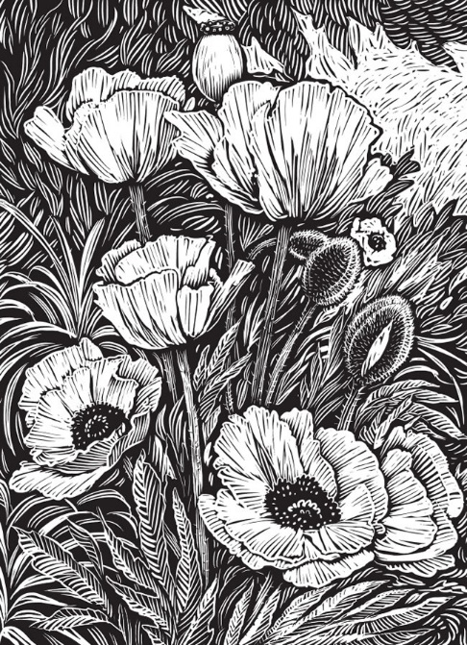

**Hot Spot**

Marjory Clements

POB 34

Hope, ID

208-264-0105

clemmj@earthlink.net

     My husband, Jim, and I moved to Hope in November 2012 from the Yakima, WA area where we had commercial apple orchards for the previous 35 years. Both of us graduated from the University of Idaho and then moved to Boise where I interned in Medical Technology.  After receiving my MT(ASCP) I became Head of the Hematology Department at the St. Alphonsus Hospital laboratory.   We later moved to Shoshone, ID and then to the Yakima area.

     My parents were city gardeners and my grandparents were either farmers or city gardeners so I grew up loving gardening.  I still treasure a few plants I inherited from my family.  I have gardened everywhere we have lived and especially enjoyed our years living on an orchard property where I had lots of land to raise both vegetables and flowers as well as various fruits and nuts.

     While we lived in Washington I  had the pleasure of taking the Master Gardeners and Advanced Master Gardeners courses and belonging to garden clubs affiliated with the National Council of State Garden Clubs and the Yakima Valley Iris Society (charter member).  I also had membership in the American Dahlia Society, the American Hemerocallis Society and the American Iris Society.  The latter two I still belong to and greatly enjoy attending their national conventions to see the latest hybrids and beautiful gardens in other states.  All of these groups provided great learning opportunities and friendships.   One of the joys I had as an AIS member was to grow for  two years some of the top hybidizers' newest irises for the Region 13 (WA, OR, AK and BC) Spring Garden Tour.  I also enjoyed entering the fresh and preserved fruits and vegetables as well as flowers in the Central Washington State Fair.

     Besides raising our two children, running our home orchard, gardening and preserving our produce I also was treasurer for my husband’s political campaigns for a dozen years and doing all that being the spouse of a politician involved.

     My husband grew up in Hope and had always dreamed of retiring here.  We now have a small property with a good slope, rocky soil and shade from neighboring trees, not to mention visits from deer, elk, moose and turkeys and about half the growing season.  With all these new challenges it is nice to be a member of BCGA with so many knowledgeable gardeners to learn from and share friendships.

s