**The Garden Gate** 

**Bonner County Gardeners Association**

**Education ~ Community Service ~ Camaraderie**



**February 2017**

*Please contribute to The Garden Gate. Informational articles, garden tips, announcements, and digital photos are welcome. For questions or comments please email* [lauriebrown54@gmail.com](mailto:lauriebrown54@gmail.com) *When emailing, please put “GG” in the subject line.*

**In This Issue**

March Gardening To-Do List

February Meeting Minutes

Hot Spot: Sean and Monica Mitzel

Cold Frames for an Early Start

Ponderosa Pine

Snow Shoe Pot Luck Pics



**March Gardening To Do List**



**Zone 3**

* Order seeds
* Sow seeds for hardy spring-blooming plants
* Remove mulch from early bulbs
* Cut back on feeding houseplants (do not feed dormant houseplants)
* Sow seeds for cool-weather vegetables
* Sow frost-tolerant perennials indoors

**Zone 4**

* Plant bare root trees
* Cut back on feeding houseplants (do not feed dormant houseplants)
* Sow seeds for cool-weather vegetables
* Sow frost-tolerant perennials indoors

**Zone 5**

* Plant dormant, hardy container and balled and burlapped plants
* Sow seeds of warm-season annuals indoors
* Remove winter mulch, lightly cultivate soil if thawed
* Prune out winter damage
* Apply dormant spray to fruit trees
* Plant or transplant frost-tolerant perennials
* Sow seeds for tender perennials indoors
* Plant bare-root roses
* Plant bare-root trees, shrubs, and vines
* Prune winter-blooming shrubs and vines just after bloom
* Plant bare-root perennial vegetables (asparagus, rhubarb etc.)
* Plant seedlings of cool-season vegetables
* Sow seeds for cool- and warm-season vegetables
* Protect tender plants from frost

**February Meeting Minutes**

**Following are the minutes for the BCGA meeting on February 1, 2017.**

Present: Gordon Fish, Howie Fennimore, Shirley Barksdale, Ann Warwick, Cindy Hayes, Janae Dale, Ellie Lizotte, Penny Goodman, Monica Mitzel, Gray Henderson, Barb Pressler, Sean Mitzel, Penny Barton, Brenda Boyster and Gail Swan

Meeting called to order @ 9:05 am

Jan minutes were approved and accepted as written.

Treasurer’s report was approved and accepted. There is a January ending balance of $2660.

**Announcements:**

At this time, 55 members have renewed their membership.

Kathy Osborne (from the Co-op) has asked if we would be interested in having a table at the annual Co-op meeting to give information about BCGA and to answer questions people may have re gardening. Shirley Barksdale volunteered to spearhead this venture scheduled for March 11, from 9-2 at the Co-op.

**Committee reports:**

**Membership classes:**

A “meet & greet” was scheduled for Jan 30 to meet the 2017 class members; it was a pot-luck to welcome the students, and a good number of current members came with lots of great food! Classes are scheduled to begin on Feb 3rd. Three of the membership classes will be held in the Event Center room and will include the Master Gardener students from both Boundary and Bonner Counties. This will allow both Dr. Bechinski and Dr. Tripepi to make fewer trips from Moscow to teach their classes.

**Fairgrounds:**

A productive meeting was held in the fairgrounds office with Rhonda Livingston and the head groundskeeper with discussions on improving the landscaping, especially in the front of the building. The addition of a bench was discussed as was ongoing maintenance to possibly be supported by the Trisha Murphy fund. Rhonda also suggested the idea that the fall BCGA plant sale be held on Saturday at the fairgrounds in the front of the building.

**Directory:**

Gordon Fish has been working on the directory as members have renewed

**Media outreach:**

Gordon Fish, Gray Henderson and Tim Gift have been meeting with Keokee to digitize the “Bible”.

They are also working on revising the BCGA website with new software and new tools to count visits to the site.

If you are not included on the BCGA Forum list and would like to be, contact either Gray Henderson or Shannon Callister to have your name added to receive emails.

**Home and Garden Show:**

Ann Warwick has been working on securing our application for the show to be held April 8 and 9 with a potential theme of season extenders.

**Pot-Lucks**:

Good time had by all who attended Patti and Carl Pietron’s on Jan 28; many went snowshoeing after the wonderful lunch.

Cindy Hayes and Bob Blair are planning on hosting a pot-luck on April 30 and Jenna and David Bertus are hosting one on June 3.

**School Gardens:**

The cottonwood tree has finally been cut down at Kootenai Elementary that was causing havoc with the garden there. Gray will paint the stump to prevent regrowth.

Brenda Boyster volunteered to help at the Southside school garden.

Michelle Murphree secured a $12000 grant from Panhandle Health to be used for items at the schools. Southside School is now going to be starting a garden. Janae ordered seed catalogues from Territorial and Irish Eyes for the gardens. Let Gray know if you are interested in helping with any of the gardens.

***Old Business:***

Barb Pressler contacted “Young Living” in Naples to arrange a field trip to see their distillation process for essential oils. She was told the best time would be in April or May and they can accommodate up to 50 people any day of the week.

**Spring Plant Sale**:

Sale to be held May 12 and 13 (Mother’s Day weekend) in front of the Bonner Mall by the theater entrance. Time to start planting and taking cuttings and dividing plants.

***New Business:***

Interest has been expressed regarding holding an advanced gardening grafting class. Gray will coordinate this through the extension educators, Kate Painter, Boundary County and Jennifer Jensen, Bonner County to be presented by Dr. Tripepi.

Meeting adjourned at 10:30

Respectfully submitted by Gail Swan, secretary

**Hot Spot**

Sean & Monica Mitzel

The Prepared Homestead. Teaching in our Home Horticulture series: “Permaculture, Hugelkultur, and Micro-climates"

45 Eichs Road

Cocolalla, ID 83813

208-304-3122

[outlanderz@gmail.com](mailto:outlanderz@gmail.com)

[joyousmon@gmail.com](mailto:joyousmon@gmail.com)

***Sean***

My family and I (Monica and 7 children) are transplants to northern Idaho, it was certainly an adventure getting here. Monica and I have been married 26 years this year and spent almost 24 years of it in the Marine Corps adventuring and learning to grow plants in a variety of climates  - southern CA, SW Arizona, northern Arizona, North Carolina, Florida, Virginia, Western Washington, and our last duty station - Okinawa, Japan. In each location we gardened, even if it was learning to grow cactus and succulents in our sandy backyard. In 2014, in preparation for retirement, I took Geoff Lawton’s Permaculture Design Course where I studied topics such as: methods of design, pattern understanding, climatic factors, water, aquaculture, soils, and earthworks. I love taking the various elements of property: water, access, structures, energy, food production, and waste; and teaching other people how they all work together in a synergistic way in order to make their homesteads more productive and resilient. Now we live on a working 40 acre homestead in Northern Idaho where we are raising animals and growing food in food forests, herb gardens, perennial and annual fruit and vegetable gardens, cold frames, and a hoop house; putting everything I learned into practice. One of my passions is propagating trees, bushes, and herbs and am learning how to graft trees. I keep an active “laboratory” in our home where I experiment with different methods of growing a variety of plants.

After our move, I took great interest in learning about Idaho forests and decided to take the program through the U of I extension to become a Master Forest Steward and then, in 2016, before our second growing season, we decided to enroll in the membership course given by BCGA which gave us an even better understanding of gardening in the Idaho Panhandle with all its unique challenges. Always wanting to learn more, we enrolled in the Master Gardener program through U of I Extension this year. There certainly is not a shortage of educational opportunities here and BCGA is a big part of that learning.

Monica and I are active in Master Forest Stewards Program, BCGA, and other groups promoting permaculture and gardening, I teach classes on permaculture through the Community Education department at North Idaho College and give workshops, presentations, and courses on different aspects of homesteading and self-sufficiency. I graduated from American Military University with Master’s Degree in Management and am a graduate from Marine Corps Command and Staff College with a Master’s Degree in Military Studies.

***Monica***

Since 1991 I have identified myself as a Marine Wife; my life was filled with adventure, migration, and variety. We never stayed anywhere longer than three years and we only did that at three duty stations, the rest were fewer. I learned to expect change and adapt to new living conditions, climates, and people. I had to learn to be stronger than I ever thought I could be through the many deployments we endured. But best of all, during my life as a Marine Wife a pioneer spirit sprung up in me. Who knew that being a Marine Wife would begin to prepare me for the journey we would be setting out on in late 2014, that of homesteading. During those 24 years I was able to mentor, teach, and encourage many women in personal development, home management/organization, from-scratch cooking, homeschooling, goal setting, and entrepreneurship (having built, run, and sold a small business of my own while moving and homeschooling three children).

Homesteading was something Sean and I talked about, planned for, and studied for almost two decades. Our vision morphed and changed over the years, some visions were better than others. If I’m remembering right, I believe back in about 1997 our homestead even included a motocross track and roller coaster (maybe one day). Being a city girl who was raised in the Seattle area, homesteading always seemed quite idyllic and peaceful. As I dreamed about homesteading I would remember all the fun-filled summers at Grandma and Grandpa’s farm – sunshine, birds, lots of goodies growing in the gardens, swimming in the river, and eating homemade strawberry rhubarb pie. Don’t get me wrong, I never imagined it would be all strawberry-pie-eating and cloud-watching, I knew we were in for work, challenges, and changes; we would have to adapt to a new culture, but I’d done that many times before so I felt pretty prepared.

But, like many other moments in my life, I wasn’t fully prepared for what reality would bring: the enormity of the changes, the plethora of skills we lacked and would have to learn “in the fire”, and the many countless hours that are involved in running a homestead. I also wasn’t prepared for the satisfaction that comes with eating food from our land (I’m always amazed by the incredible taste every time I eat a rabbit we raised and butchered, a raspberry from our patch, or an egg from our layers). We finally have a piece of land to call our own where we can establish roots and leave a meaningful legacy for our seven children.

One of my primary interests for many years has been the study and use of medicinal herbs. Last year, for the first time, I was able to start my own culinary and medicinal herb garden which has been so exciting for me. I continue to learn more about our unique climate and micro-climates to enable me to grow more successfully each year giving me the advantage of having a “farmacy” right out my front door! Aside from gardening I enjoy food preservation, playing piano, studying the use of herbs to enhance health, and our family loves to hike throughout the summer months.

The people within BCGA have been an amazing resource for us as we learn to grow food and herbs in this area of the U.S. - they are a wealth of information that has come from their many years of gardening experience and are always happy to share it. On a side note, the food at all the gatherings is always delicious! We are blessed to be part of this incredible group.

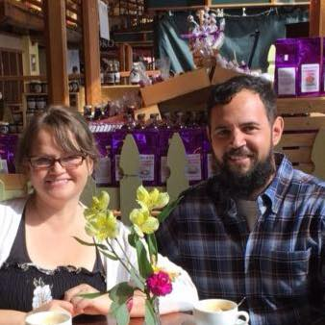

**Cold Frames for an Early Start**

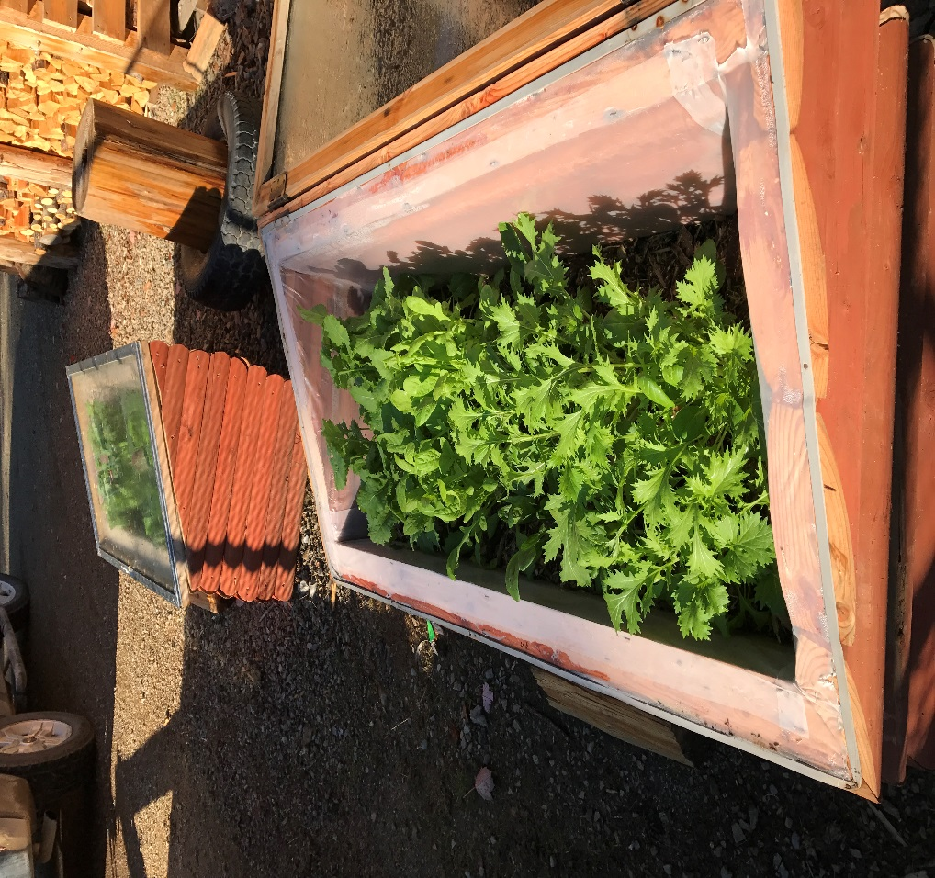

Assorted Greens grown in Late Fall

Utilizing cold frames to get an early start and extend the season is one of easiest and most reliable ways to get a jump on the growing season.

Have you ever listened to people talk about building high tunnels and greenhouses? They often are mired in cumbersome grant programs with costs in the thousands and more often in the tens of thousands of dollars. For the small space gardener or self-sufficient homesteader there is a much better way with the cold frame!

**What is a Cold Frame?**

A microclimate miracle! Well, not really but it does create a microclimate that gives the grower increased capability. Essentially, a cold frame is a small enclosed space that acts like a greenhouse on a small scale. It creates a microclimate of warmth and protection from snow, ice, frost, wind and critters. It’s often a rectangular box with angled glazing on top facing south.

**How Can I Use it?**

Cold frames are great for many purposes. The first, which was already mentioned, is protection. The pants in the cold frame are protected from harsh weather. They also are easy to “harden” and prevents critters, whether from below or above, to get at your precious plants! Warning: if you have goats they will stand on top of cold frames if they have access. Control the access or make sure the cold frame is strong enough to handle the occasional goat!

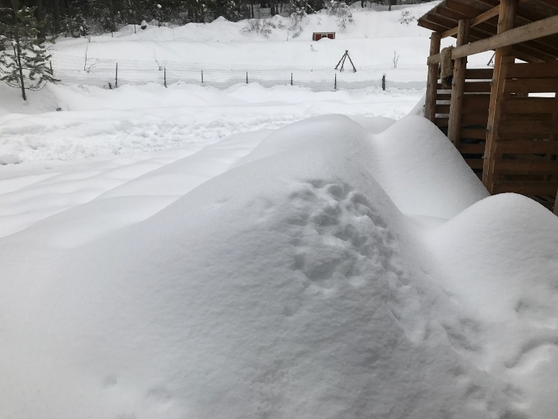

There are Cold Frames under that Snow

Another great use for a cold frame is season extension. There are a lot of factors involving growing season and it depends on the individual situation on how much a cold frame can extend a particular property’s frost free days but it’s very safe to say a cold frame can extend the season AT LEAST a couple of weeks on either side of the growing season.

Cold frames can be used to start seedlings instead of, or in conjunction with, germinating plants indoors under grow lights. Another related use is to take starts that were germinated indoors and use the cold frame to harden off plants in preparation for transplanting. Of course, cold frames are great for production. Having even a small amount of fresh, home grown produce in late fall or even winter is a wonderful treat.

It is not hard to understand that cold frames can be turned into mini “hot houses” to grow crops like tomatoes and peppers in marginal climates. In North Idaho there are wide variations of microclimate that make getting ripe tomatoes and peppers for some people very difficult.

**What Types of Plants Should I Grow in a Cold Frame?**

Typically you will find cool weather crops growing in cold frames. Very common are lettuces, spinach, kale, cabbage and many types of root crops. That list is not exhaustive but is an indicator of how a family can plan out their food production. As indicated above a cold frame can be used as a “hot house” for warm weather crops as well. For example, if you live in a climate that is difficult to grow cayenne peppers the cold frame could be used to get a jump on the season or used to house the plant through the season. It really depends on your growing goals!

**What Types of Materials Can I use to Make a Cold Frame?**

A quick search shows that cold frames can be made out of just about anything. Keep in mind that using treated lumber is not recommended unless some kind of barrier is used between the wood and the soil. Straw bales are another common material to use for cold frames. Talk about simple! As far as the glazing is concerned anything from greenhouse plastic remnant to repurposed windows or old shower doors can be used. Another effective material for cold frames is earth! Dig a rectangular hole and cover it and you have a simple cold frame that is using the thermal mass of the earth to help maintain temperature.

**Where Should I Place the Cold Frame?**

First, you need a south facing area for your cold frame. Use true south as much as possible but don’t worry if you are off a little. In most cases, using magnetic south and then nudging it a bit toward true south works just fine.

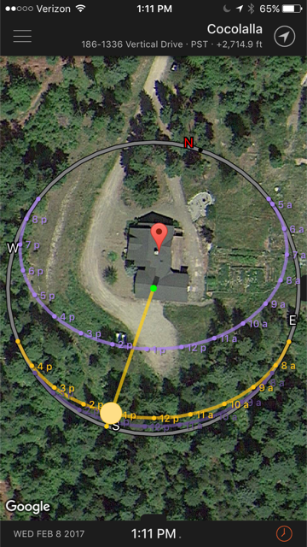

Another important aspect is the angle of the glass. Again, don’t get analysis paralysis. The optimal angle depends on the main time of year you plan on using the cold frame. If you are using it year round then a compromise angle like your latitude – 15 degrees might work well. If your main use is going to be late fall, winter and early spring then a steeper angle like your latitude + 10 degrees might be more applicable. For us, the main times of year are fall and spring. We are at 48 degrees of latitude and choose to angle our glass at 35 degrees. This gives us the flexibility to use the cold frame year round although a much steeper angle would be more effective in deep winter.

Finally, it is critical that the cold frame or frames be put in a place that is convenient for the gardener. It should be in sight and in mind. The ideal location is in a “kitchen garden” type location. The ideal place would be right outside your door and in a place where you pass it and/or see it often. For permaculturists this element definitely belongs in zone 1!

**Tips and Tricks for Cold Frames**

* Make a “hot” compost pile on the bottom to aid in heating the frame during cold weather
* Use a thermal blanket to cover the frames during cold nights
* Cold frames heat up fast, be prepared to regularly vent the frame
* Place a thermometer in the frame to understand what the microclimate is doing
* Avoid treated lumber to construct the frame unless using a barrier of some kind
* Don’t use glazing that is tinted or is meant to reflect light in anyway

**Trees of the Idaho Forest: Ponderosa Pine**

*(Pinus ponderosa)*

Historically, ponderosa pine forests predominated on warm-to-hot, dry sites at the lower elevations along the east slope of the mountains and in major river valleys in the Northern Rockies, Middle Rockies and Palouse grassy, semi-arid plains (steppe) Ecoregions. Mature ponderosa pine forests were commonly quite open, a condition that was maintained by intermittent low intensity fires averaging every 5 to 25 years. These surface fires consumed the needle duff and killed most understory trees. Bark beetles killed individual or small groups of aging or stressed trees, which were eventually replaced by regeneration that had survived the fires.

Ponderosa pine is now less common, having been replaced by denser forests of Douglas-fir or grand fir. Acreage decreased by 44 percent for Idaho as a whole during the period 1952-87. The change is a result of fire suppression and timber harvesting. Without fire, the more shade-tolerant Douglas-fir and grand fir become established and outcompete the ponderosa pine. Early harvesting of ponderosa pine accelerated the shift in composition toward Douglas-fir and grand fir. The net result has been a change from predominantly semi-open, mature ponderosa pine forests to dense, younger forests, many of which are multi-storied, shade tolerant species more susceptible to fire and disease.

The changes in forest composition and structure have favored a number of native insects and diseases. Douglas-fir dwarf n-Listletoe builds up to high levels in dense, slow-growing stands and when infected overstories provide an infection source for understory trees.  
Bark beetles kill ponderosa pine at increased rates in the dense stands, especially during periods of drought. Defoliating insect outbreaks periodically occur, with most significant effects occurring in multi-storied Douglas-fir and grand fir stands.

Altered forest structure and composition have also increased risks from wildfire. Fire suppression has permitted greatly increased ground fuels, with the multi-storied condition creating a "fuel ladder." Fires often bum hotter and more extensively than they did in the past, creating conditions where many fires can no longer be contained.  
More than half a million acres burned between 1989 and 1994 on the Boise National Forest. In the past, fires in this forest type were primarily low to moderate intensity, and most of the large ponderosa pine survived. A relatively small amount of the forest burned severe enough to kill all the trees.

Unlike the low-moderate intensity fires of the past, some wildfires now are lethal across large areas with the potential for damaging the productivity of soils and increasing erodibilit) through the consumption of organic matter and high temperatures especially when coarse textured soils are involved.

Common throughout the western United States and the southern portion of British Columbia, the ponderosa pine is a curious tree. Individual specimens from different regions across its growing range exhibit considerable variation in needle length and thickness, cone size, bark color, and wood texture. Needles can range from 5 to 10 inches in length, and occur in bunches of two or three. Ponderosa pine cones are oval in shape, are generally from 3 to 6 inches long, and feature a stiff prickle on the end of each cone scale. The bark of a mature ponderosa pine features broad, irregular, scaly plates that give the impression of belonging to a jigsaw puzzle.  
Ponderosa pines grow to heights of 230 feet, though trees in the 150-foot range are more common. The trunk of a mature ponderosa pine has few lower branches, and can be from 5 to 8 feet in diameter.  
The fine-grained, moderately strong, lightweight wood of the ponderosa pine is used in such applications as decorative moulding, shelving, interior paneling, and crating material.

*From Idaho Forest Products Commission*

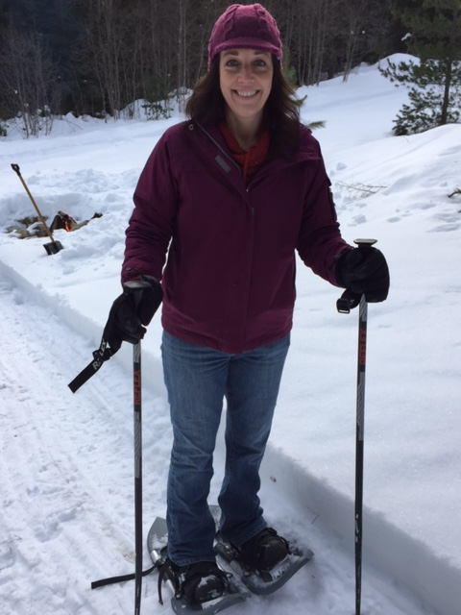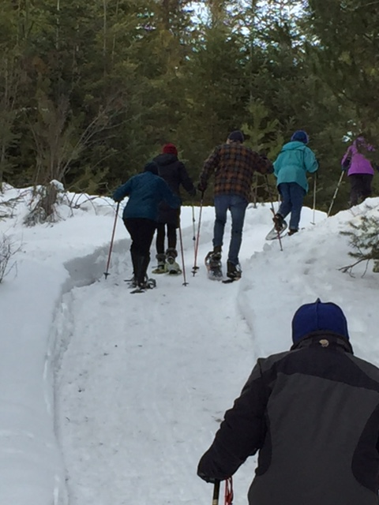

Brenda Boyster & company at the snow shoe party & potluck. First time on snow shoes!