**The Garden Gate** 

**Bonner County Gardeners Association**

**Education ~ Community Service ~ Camaraderie**



**October 2016**

*Please contribute to The Garden Gate. Informational articles, garden tips, announcements, and digital photos are welcome. For questions or comments please email* [lauriebrown54@gmail.com](mailto:lauriebrown54@gmail.com) *When emailing, please put “GG” in the subject line.*

**In This Issue**

President’s Message

November Gardening To-Do List

Birthdays!

October Meeting Minutes

Hot Spot: Bob Baker

**President’s Message**

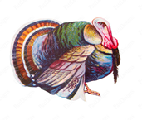

The turkeys in our neighborhood are growing in size. I told them we’re having ham for Thanksgiving. They were most appreciative.

There was an explosion of mushrooms in my yard and on the trail this year. I found a turkey tail mushroom on one of my hikes the first of October. **Mushrooms** was one of our popular Home Hort classes this Fall taught by Art Church. Barb Pressler found 30 Death Angels (amanita) in the parking lot of a local business. Beautiful but deadly. Be careful if you are out mushroom hunting this Fall.



Death Angel Turkey Tail

There’s been a good turnout of BCGA members and the public for the **Fall Home Hort** series. A BIG Thank You goes to Janae Dale and Gail Swan for their hard work in lining up the outstanding slate of speakers for this Fall. We even added a late entry class (Orchards by Art Church) to the roster for October 19 to round out the season.

The BCGA **Christmas Party** is just around the corner. A meat and vegetarian entrée will be provided. Please bring a potluck dish or wine to share. Circle your calendar for Saturday December 10. The morning of the 10th Penny Barton and her volunteers will transform the Ponderay Event Center into a festive environment to set the mood. Let her know if you are interested in helping with the decorating. We will do a White Elephant gift exchange.

There was a record turnout (13 hardy souls) who participated in the **Fall Highway cleanup**. Thanks Tim for keeping us on task. We’ve completed our 2 year contract of 4 scheduled pickups. This last one included sowing wildflower seeds 10 feet from the road (see pictures at end of this Garden Gate issue). We picked up 19 bags of trash. The BCGA Board voted to extend our contract for another 2 years. When you’re out near the Blue Heron/Conoco station at Samuels Rd. and Elmira Store look for the Bonner County Gardeners road sign at mile marker 489 and 491.

The **Farmers Market** is winding down for the season. BCGA will have a booth on Oct. 15 open to the public. BCGA members have signed up a number of people who have gardening questions or are interested in finding out about our organization. Thank you Sandra and all the BCGA members who have staffed the booth despite the wind, rain or sun. Look for the new aprons sporting the BCGA logo that volunteers will start wearing.

We are still in need of BCGA members to fill the office of **President or Secretary** for 2017. Please contact Cindy Hayes – President 2016 or a BCGA Board Member is you are willing to step into either of these positions.

Cindy Hayes – President – 2016

2631104

cmhayes63@gmail.com

**October Gardening To Do List**



**Zone 3**

* Cut back on feeding houseplants (do not feed dormant houseplants)

**Zone 4**

* Cover perennial, vegetable, bulb, and strawberry beds for winter
* Plant winter- and spring-flowering bulbs
* Divide and replant crowded fall-blooming bulbs after leaves yellow
* Buy spring-blooming bulbs
* Cut back on feeding houseplants (do not feed dormant houseplants)
* Protect roses for winter

**Zone 5**

* Plant winter- and spring-flowering bulbs
* Divide and replant crowded fall-blooming bulbs after leaves yellow
* Buy winter- and spring-blooming bulbs
* Cut back on feeding houseplants (do not feed dormant houseplants)
* Protect roses for winter

**October Meeting Minutes**

**Following are the minutes for the BCGA meeting on October 5, 2016:**

**Members Present:** Cindy Hayes, Patti Pietron, Ann Warwick, Howie Fennimore, Janae Dale, Penny Barton, Tim Gift, Gail Swan, Shirley Barksdale, Barb Pressler, Gray Henderson, Penny Goodman, Johna Diderich, Sandra Gevurtz

**Meeting Called to Order: 9:00am**

**September Minutes:** No corrections noted. Penny Barton motioned to accept the minutes, seconded by Penny Goodman. Minutes approved.

**Announcements:** Bridge club asks we stack tables vinyl to vinyl to avoid scratches

Cindy Hayes passed around a “Thank You” cards to the two women who worked on our apron for members at the meeting to sign.

**Treasurer’s Reports:** Penny Barton reports a balance of $4,649.48.

**Committee Reports**

**Home Horticulture** – Gail Swan reports we had about 42 attendees at the Mushroom class and anywhere from 20 – 25 attendees at the other classes. A class on Orchard given by Art Church will be added due to lots of interest expressed by the Mushroom class students. The class will take place on October 19. Ann Warwick thanked Tim Gift for getting the Home Horticulture classes announced on the radio. Penny Barton suggested using the second side of our whiteboard to announce the Home Horticulture class in the window of our office.

**Healing Garden** – No report. Cindy Hayes said that there would be a cleanup day sometime in October.

**Speaker’s Bureau:** No report. Marrion Newsam Banks is still interested and has submitted a proposal to Gordon Fish regarding the program and listing it on our website. Tim Gift expressed interested in what Marrion is proposing. Cindy Hayes will send a list of interested parties to Marion so she can set up a meeting.

**Farmer’s Market**– Sandra Gevurtz reports that 6 people who visited our booth were interested in becoming members. October 15 is the last day of the Farmers Market. Our booth will have a Fall Cleanup theme.

**School Gardens** – Gray Henderson reports that it’s harvest time in the gardens. Janae Dale is getting bids for the removal of the cottonwood tree that’s shading the garden at Kootenai. She will explore the possibility of Home Depot contributing to the cost of the removal. Janae will keep board members posted through emails as the process continues.

**Highway Cleanup** –Tim Gift reports that 13 BCGA members showed up for cleanup and picked up 19 bags of trash in addition to larger items that couldn’t be bagged. The Highway Dept. asked BCGA to be part of their wildflower program. So along with picking up trash, the group spread two test areas with wildflower seeds. The Highway Dept. reported that in the 5 northern counties a total of 120,000 pounds of trash the equivalent of 15 residential trash trucks was picked up this year. This amounted to a cash savings for the counties of $88,000.00. Tim reports that we are at the end of our two-year commitment for highway cleanup. Penny Barton motioned for BCGA to sign up for another two years. All were in favor, so BCGA will continue to do highway cleanup for another two years.

**Potlucks** – No report. No potlucks scheduled currently.

**Fairgrounds**– Penny Barton has attempted to contact Rhonda and will continue to do so.

**Membership**– Penny Barton is getting lots of names of interested parties. She will send out an email to all of them in December. If she fills the class she will not advertise. She will meet with the U of I and the Boundary Extension Office to combine classes that have the same instructors in order to best utilize these valuable teachers. Gray Henderson will organize the meeting.

**Website/Directory**– Gordon Fish to include Aspen’s links on our website. BCGA will only list sites with .edu or .org in order to avoid unwanted advertising from other types of links.

**Old Business**

**BCGA Aprons** – Cindy Hayes brought in the aprons and they are beautiful. She also passed around “Thank You” cards to the two women who worked on the aprons for members at the meeting to sign.

**Electronic transfer of data** – Cindy Hayes reports that almost all of the updates have been made to the data. Tim Gift reports that the conversion will be a wintertime project.

**Listserve** – Gray Henderson reports that all’s well with Listserve.

**New Business**

**Nominations** – Cindy Hayes reports that no nominations have come in for President or Secretary. Gail Swan says she will step into the Secretary role if nobody else can be found. Sean and Monica Mitzel will each fill a board opening.

**Christmas Party** – The party will be held on December 10th. Cindy Hayes will get bids on food for this event. She will also send out the invitations. Penny Barton will do decorations.

**Internet Service** – Gail Swan says we have a new secured password.

**Music Conservatory** – Cindy Hayes has approached the Music Conservatory in regard to having students play at our Garden Tour. The Conservatory would like a donation for this. Shirley Barksdale suggested we up our ticket price for next year’s tour.

**Chamber of Commerce Membership** – Gray Henderson questioned if this membership is worth having. It is $120.00 per year or $10.00 per month. This will be discussed at a later date as we have just renewed for 2017.

**Meeting Adjourned at 10:30**

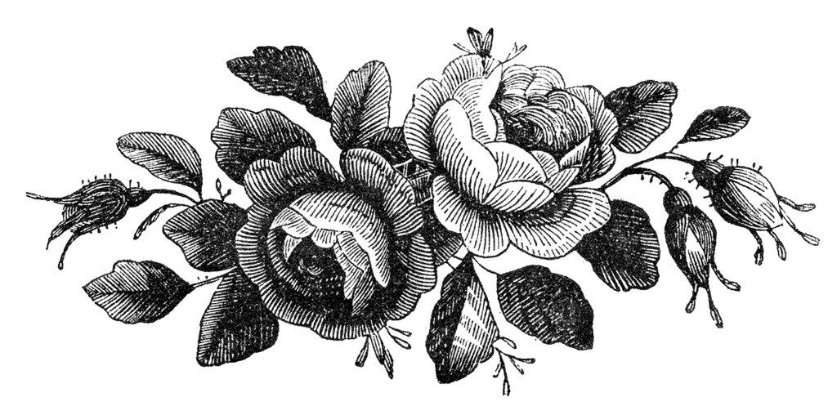

**Hot Spot**

Bob Baker

624 Whiskey Jack Rd.,

Sandpoint, ID 83864

290-1864

[kiwibob@nctv.com](mailto:kiwibob@nctv.com)

**

My name is Robert Baker, and I have lived in Sandpoint for 12 years, moving here from Vashon Island, Puget Sound Washington.

I have been a member of the BCCA for three years (sad to say, now that I have taken up sailing once again, I have not helped out has much as I should have, I also what to say what a wonderful group of people the BCCA members are, and it has been a real learning experience for me)!

I started experimenting with gardening during my thirty year career with the Los Angeles Police Department, when I lived in Downey California, which is located about eleven miles southeast of downtown Los Angeles.

Having the career which I had, where I dealt with mostly the dark side of life (crime, death, and children living in poverty just to mention a few), but that said, I still loved my job, as I felt I was helping people and it was all very exciting at the same time. When I left work each day it was nice being able to channel my activities into other things that gave me an escape from the things I had to deal with at work.

Gardening was one of the activities I found to be enjoyable and relaxing for me. My main problem was that I did not have very much room for a garden, so I had to limit myself to what I could grow, being as creative as possible. I love citrus trees, orange, lemon, lime, grapefruit, and all the varieties in between. I ended up planting dwarf trees in the limited space I had and grew tomatoes and flowers in pots.

When I retired I and moved to Vashon Island where I had two and a half acres to have what ever kind of garden I wanted. I made seven raised vegetable gardens, and experimented with raising different things over the years I lived there, with corn, beans, cucumbers, and zucchini always being my favorites. I also grew several kinds of cherry trees (rainier being my favorite) along with Asian pears, and apple trees. Black berries grow wild on Vashon Island and are considered a weed by a lot of people living there, but I loved them and they were one of things I did not have to plant. The one thing though which I could not grow, and to this day still miss are my citrus trees, the fruit is wonderful, but it is the smell of the blossoms which I miss the most!

My gardening was not limited to vegetables and fruit trees, I ended up landscaping the whole yard, it being a clean slate to start with, which became a monumental task, but one I enjoyed. There was a rock retaining wall around half of the front of the house, which went from about three feet to four feet at its highest. Whenever I went on day trips or camping trips, I always looked for small native plants that were growing between rocks on the side of hills. I would bring them back and plant them in my rock wall, which added a wonderful effect to the garden.

When I moved to Sandpoint and bought the house in which I’m now living, once again I found I had pretty much a clean slate with which to start. There were some mature trees, but not much in the way of other plants. The house, though, required a lot of work and I spent the next several years working on the house, saving the gardening till that was completed.

Once my main project, (the house), was complete, I moved on to working in the yard. I planted three willow trees at the bottom of the backside of my property on the water’s edge, and higher up the hill planted one row of apple trees and one row of cherry threes. I also planted raspberries, blackberries, and blueberry bushes. I then finished the back side of the house with matting and mulch, making a garden with different types of plants and trees, built a walkway to my dock, and an arbor over the walkway on which I’m now growing Reliance grapes.

In the front of the house I tripled the flower garden area which had been started and added borders to it. I also added several partial fences to the yard, not for fencing things out, but as a backdrop for the flower garden I planted in front of it. I then added more trees for their different colors, spring and fall. I also took a third of my front yard and converted it from lawn to a forest garden where one can go and sit, while enjoying being surrounded by all the different types of plants.

The first thing I did when making the forest garden was to kill all the grass, I then covered it with a high grade matting, and covered the matting with mulch 2” thick. It took me 2 ½ dump truck loads of mulch, all carried in by wheel barrel, one load at a time. Once that was complete I had a blank canvas, just like an artist before he starts to paint. As we all know plants are not cheap, especially at the start of each season. I needed a lot of plants, so what I did was wait till the end of each season when you can buy them on the cheap compared the start of the season. I did not want any order to the forest garden (except the border). I just bought things I liked and planted them where I liked, not really knowing how they are going to look, as they were not looking too good most of the time when I bought them at the end of the season! It took me three years to get to the point I felt the forest garden was finished, but I loved doing it, and I’m happy in the way it turned out. I have now reached the stage in my gardening that I have no more room to plant things in the ground, but all is not lost as people have created wonderful things called pots!

As I have no real place for a vegetable garden, the only vegetable I have been growing is tomatoes (even if it is a fruit)! The good thing about pots for me is the back of my house faces south, and I have a brick wall I can place the pots up against. They heat up faster and the tomato plants grow faster, but the downside is that they dry out faster and require watering most every day!

A neighbor of mine brought me back some Hawaiian Pepper seeds, and those little seeds got me hooked on growing peppers! I ended up studying and learning all I could about peppers. They are a fascinating plant, and fun to grow without much fuss. I enjoy drying them out, grinding them up, and mixing different peppers together for different foods. When the season is over, one only has to cut the pepper plant back to its trunk maybe about 12 inches from its base, store it away where it will not freeze to death over winter, and come next season it will start growing again (if not before) into a new pepper plant. I have attached a picture of my Hawaiian pepper plant which I let grow for two years, but this year after harvesting the peppers I will be pruning it back, as it is just getting too large to keep bringing into the house for the winter.

I am going to end this by saying gardening is something special to me; it is an emotional thing, a pleasurable thing, and relaxing thing all in one. It requires no knowledge of gardening to be enjoyed (I’m a fine example of that), and can be enjoyed by everyone. It does not cost an arm nor leg, only your effort to do it, and isn’t that what it is all about anyway?

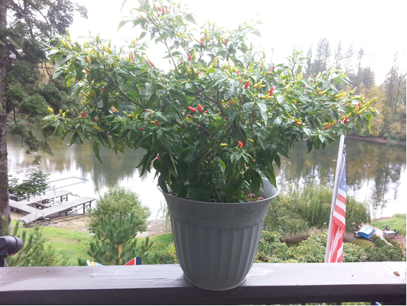



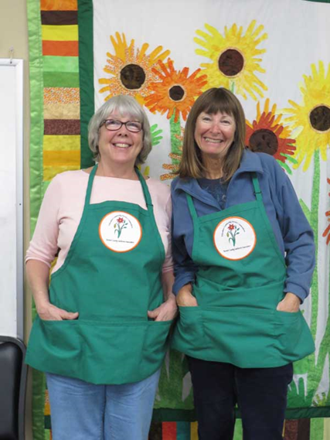

BCGA Members Penny Goodman and Patti Pietron modeling our new BCGA aprons